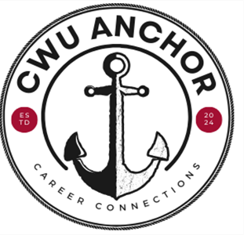
Email Template: Conversation #1
Hello,
I just wanted to send out a quick reminder about our meeting next week and give you a little more information about our conversation. Across the University, we participate in a program called CWU ANCHOR that is designed to help you make me aningful connections between what you’re learning in the classroom and what you’re learning on the job. Making these connections contributes to your overall academic and social success. Below is the list of questions that we will discuss during our conversation. Please take few moments to look over these questions and think about your answers prior to our meeting.
- How is this job fitting in with your academics?
- What are you learning here that’s helping you in school?
- What are you learning in class that you can apply here at work?
- Can you give me a couple of examples of things you’ve learned here that you think you’ll use in your chosen profession?
See you next week!
Sincerely,

Email Template: Conversation #2
Hello,
I just wanted to send out a quick reminder about our meeting next week. We will be discussing what you are learning in the workplace and how this connects to your academics. Below is the list of questions that I will be asking you during our conversation. You may notice that these questions are the same ones we talked about last time. For this meeting think about anything new you have learned or noticed since we met last time.
- How is this job fitting in with your academics?
- What are you learning here that’s helping you in school?
- What are you learning in class that you can apply here at work?
- Can you give me a couple of examples of things you’ve learned here that you think you’ll use in your chosen profession?
See you next week!
Sincerely,

