Fall 2025 end of Quarter Procedures for
Canvas Course Management

Winter 2026 Canvas Classes Added December 10th, 2025

Multimodal Learning & Canvas Updates

Folio and ePortfolios Sunsetting June 30th, 2026
Both Portfolium (Folio) and ePortfolio will be fully retired on June 30, 2026. After this date, only the new Portfolio solution will be available to use in Canvas. Content from both Folio and ePortfolio can be exported by following these guides. The new portfolio solution will be available very soon.
- How do I download the contents of my Canvas native ePortfolio?
- How to export content from Canvas Student ePortfolios/Folio as a student?

AI Tools in Canvas
All current AI tools in Canvas are “Feature Options” that can be turned on in the course settings area. Click the “Feature Options” tab at the top.

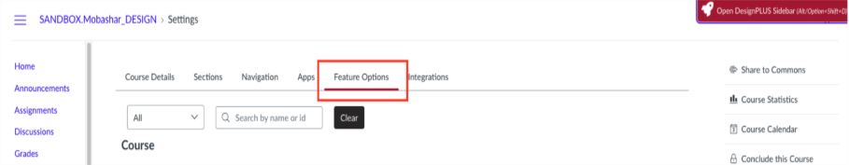

Smart Search - Smart search is an AI tool that allows instructors to search for content within their Canvas course. Once enabled, you will see the “Smart Search” option in your course navigation menu (Blue links on the left). This is available for both instructors and students. Students can only search for content they have access to.

Discussion Summary - Discussion summary allows users to get an overall summation of the responses using AI. It analyzes the responses and then creates a summary of what participants are saying. It creates a consensus or themes within the responses.

End of Quarter Canvas Procedures
IMPORTANT: Set-up Canvas Now for A Student with Incomplete
If you have a student taking an incomplete, please follow the updated guide to allow the student to continue to submit assignments after the course has concluded. If you do not set up the incomplete access before December 16th, 2025, you will have to contact Multimodal Learning to give access. Set Up Canvas For A Student With An Incomplete.
Posting Final Grades
Note: It is CWU policy that course gradebooks should be kept for two years. Canvas is not the official repository for grades, be sure to download the gradebook as an archive.
- Finalize and Download Your Grades: Make sure all graded assignments have a graded value. Instructors need to manually enter a zero for any missing submissions/assignments for the final grade to be accurate. Instructors using the Grades in Canvas should download and save a copy of the scores in the gradebook as a .csv file. This file will open in Excel. Here is the guide: How do I download scores from the gradebook?
- Post Grades to MyCWU: Official grades need to be posted to MyCWU. Canvas is not the official repository for grades. To post grades, log into MyCWU. Navigate to Faculty Toolbox/ Faculty Center/ Grade Roster. For assistance with entering grades please contact the Registrar’s office 509-963-3001. Grades must be posted by 10pm on December 16th, 2025.

Concluded Canvas Courses
Concluded courses are an archive of course content and student work. Faculty can import content from a concluded course and view grades and submissions. Students can access course content in a read-only format (excluding tests/quizzes).
- STUDENTS –Spring courses conclude for students on the day grades are due, December 16th, at 11:59pm. Students can access content from a concluded course in a read-only format. Tests/quizzes or anything that is locked using the availability feature remains inaccessible. Instructors can restrict student access to course content after the course term has ended if preferred: How do I restrict student access to a course before or after the course dates?
- FACULTY - Courses conclude for faculty at the end of the following term. All active courses will be visible in the Canvas Dashboard: How do I customize my Canvas Dashboard?
  - Peer Review – If other faculty members need to be added to a course for peer review purposes, they can be added prior to the course conclusion date for students (see above): How do I Add Users to a Course , please be sure to select the “Peer Review” role.

