Equity & Services Council
Minutes
January 21st, 2022
Friday at 1:08 p.m.
Call to Order:

- BSU
- CASA
- EQuAl
- FASA
- FGSO
- MEChA

Other Attendees/ Non-Voting Members:
- Arryn – Wellness Center
- Madeline Koval – ASCWU President

Approval of Meeting Minutes:
Motion to approve: BSU
Seconded by: EQuAl
Motion passes: 6-0-1

Additions or Corrections to Agenda:

Approval of Agenda:
Motion to approve: BSU
Seconded by: FGSO
Motion Passes: 6-0-1

Org Report:
BSU – Solomon (he/him/his)
- Next week – Kahoot of Black History Month
- Auditions Jan 31st- 1st two weeks of Feb
- … planning in Ellensburg
CASA – Cathy
- First meeting this Friday
- Akwaaba night – SURC Ballroom at 5:30pm
- Met with CASA founder for member recruitment
EQuAl – Mayyadah (she/they)
- Meeting on Tuesdays at 6pm via zoom
- Tabled at involvement fair
- Preparing for pride week
- Created a pride week committee – looking for more members
  - Contact mayyadah.zagelow@cwu.edu
- Working on pride slogan for this year
FASA – Patricia
- First virtual game night last night
- Tabled at involvement fair
- Virtual meetings for the rest of the month
- Preparing for PON
- Meetings Thursdays at 7pm
FGSO – Zitlalli
- Had a game night last meeting
- Meetings still Thurs Farrell 417 4-5pm in person
- No meeting next week
- FAFSA workshop host via zoom 3-5pm Jan 27th, link on Instagram @cwufgso
  - TRIO representative and financial presentation by a TRIO program EOC
LSO - Absent
MECHA – Randy (he/him/his)
- Jan 26th at 5pm black 202 hybrid meeting

ESC Executive Board Report
ESC Chair: Mariah Minjarez, she/her/hers email: ASCWU.Equity@cwu.edu
- Next ASCWU Public Meeting will be Monday, January 24th at 1 pm in the SURC Pit
- ASCWU Updates/Events
  - Vacant student senate positions include:
    - 2 senators at large
    - 1 transfer senator
      - 1 international senator
      - Senators for the College of Educational and Professional Studies (CEPS)
  - Wellington Wednesdays will be every Wednesday from 12-2 pm in SURC 236 and via zoom
  - Virtual lobby day is Jan 27th-28^{th,} must participate in training on the 26th from 7-8 pm via zoom
  - Virtual Lobby Day Training from 7-8PM https://cwu.presence.io/form/virtual-lobby-day-sign-up-form
  - CCI Open Forum - Feb 17th 6-7pm Thurs
  - CCI Open Forum Hour Submission
Executive Assistant: Andrea Gaeta, she/her/ella, Email: ASCWUCommunityAsst@cwu.edu
- Office hours
- MW: 1-4pm or via zoom
- F: 10am-1pm
- Free Covid Tests (4 per household, no strings attached) - https://www.covidtests.gov/
- Civic Engagement Hour Opportunities
- Lobby days
- Fresh Check Day
- Wildcat Pantry Takeover (as many hours as they would like)

Community Programmer: Judy Brewer, she/her, they/them. ASCWUProgrammer@cwu.edu
  - Parade of Nations
  - Still looking for people to table and/or perform! Signup form: https://forms.office.com/pages/responsepage.aspx?id=wdaR-NaRS0SnANNxkQcWx_nmT8iJAKhHiPuERHbM3_JUMjVTUVg2TkFNVko4V0I2WDVOWlI1MFQyRi4u (Link is also in our Linktr.ee)
    - Programmer-sponsored service hours
- 1.5 for tabling.
- 2.5 for performing, with submission of practice time.
- T-Shirts!
- 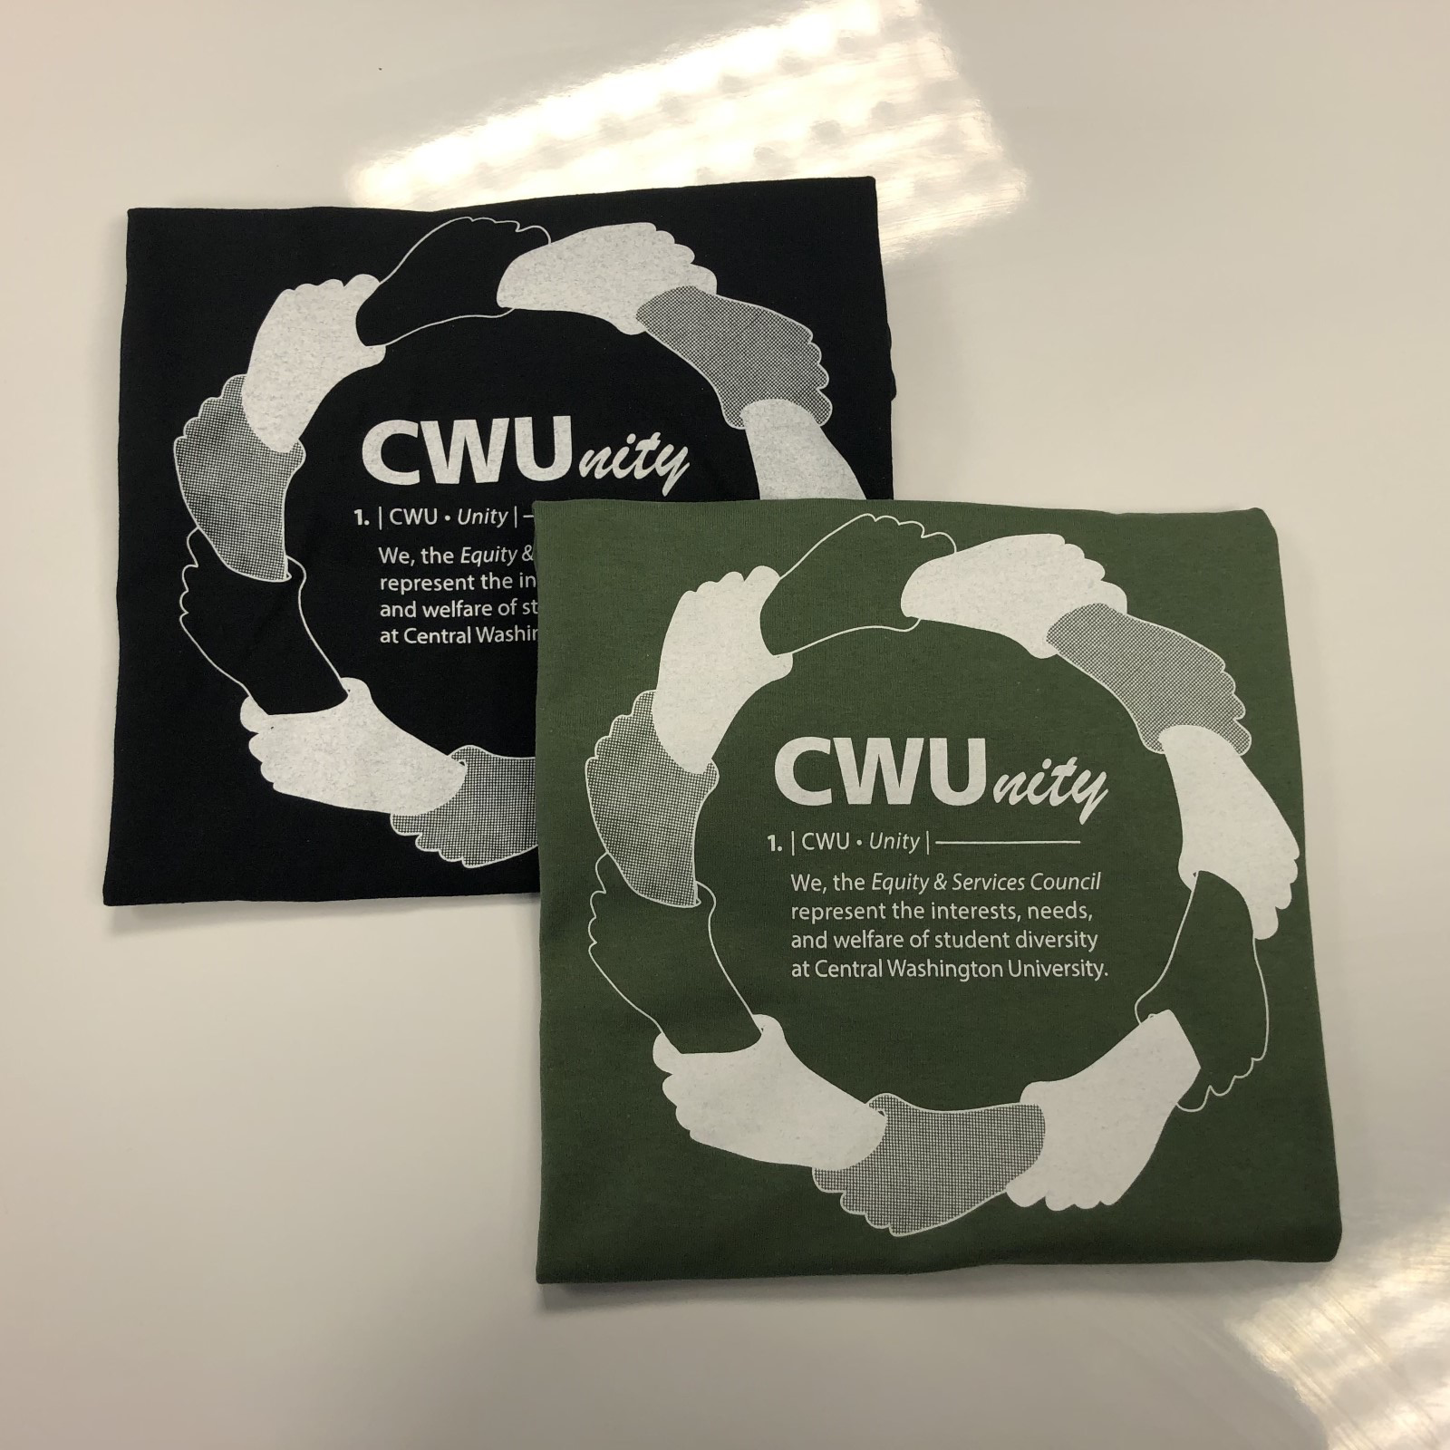

ESC Advisor: Justin Santoli, he/him/his, email: Justin.Santoli@cwu.edu
- Updated DEC Office Hours: Open at 10 am Mon-Fri: 8-10 am by appointment only
- Graduation Updates:
  - Still holding various meetings to identify funding sources; many factors to consider such as budget cuts, safety issues around food and large in-person events, uncertainty of Spring quarter guidance on programming, etc...
  - Please fill out this brief survey by January 31st: https://forms.office.com/r/nBCrZG1ZuS
    - Get 1-2 representatives
    - This will help us make a strong case to request additional funds based on need.
    - Speak with your graduation planning teams and have 1 or 2 folks complete survey for clarity of communication
    - Please email me the names of your graduation planning teams so I can send targeted information!
    - Note about combined graduation questions.
Graduate Assistant: Maritsa Rodriguez (she/her/hers)
- Find Your People: CASA will be Feb 18th at 5:00pm in room 105. We will also be providing a zoom link.
- IG Take over (especially PON participants)
  - Orgs that can participate

Old Business:
- Funding Requests
  - BSU

New Business:
- Funding Requests Voting
  - Q: will John Thomas be a contract? Potentially
  - Discussion: None

  - Motion to approve: CASA
  - Seconded by: EQuAl
  - Motion passes: 5-0-2
- Vision, Mission and Values discussion: https://jamboard.google.com/d/1N_aBAwN4s9ZyANjDStkAunrenmrstufSqlcMHC7FTi4/viewer?f=0
  - Notes: under CCI teams

Student Senate ESC Representatives
- Still have vacant positions

Issues/ Concerns/ Announcements:

Public Comments:
- Arryn (wellness center):
  - If y’all would like to share material with the wellness center for promotion! At wellness@cwu.edu
  - Monday is deadline at 5pm for Sex and Relation (WLA credit) workshop that is 6 weeks long
    - Free food!
    - Application: http://www.cwu.edu/wellness/PATHworkshop
  - Fresh Check Day: Feb 9th 12-4pm SURC main floor
    - Mental health discussion
    - Love for orgs to participate
    - Counts for Civic Engagement hours!
    - BU & EQuAl booths
    - Paint your art out – therapy through art mindfulness booth
    - Email wellness@cwu.edu or Sabeth.Jackson@cwu.edu
  - Wellness Wednesday – creating galaxy jars, tabling 1-2pm

Adjournment: 2:55pm

Next meeting January 28th, 2022, at 1:00 p.m.

