Equity & Services Council
Minutes
February 11th, 2022
Friday at 1:00 p.m.
Call to Order: 1:05

- BSU
- CASA
- EQuAl (tardy)
- LSO
- FASA
- FGSO - A
- MEChA

Other Attendees/ Non-Voting Members:
Brandon Wear-Grimm (he/him) – SURC Accounting
Arryn Welty (she/her) – Wellness Center

Approval of Meeting Minutes:
Motion to approve: BSU
Seconded by: CASA
Motion passes: 5-0-2

Additions or Corrections to Agenda:

Approval of Agenda:
Motion to approve: BSU
Seconded by: FASA
Motion Passes: 5-0-2

Org Report:
BSU - Solomon Kairu (he/him/his)
- In person auditions are over but online auditions are going until the end of Monday!
  - Please spread the word! To audition online, go to the IG bio of @cwu_bsu and submit a video!
- On Tuesday, we had our game night meeting over Zoom, we played Gartic Phone and Jackbox
  - Our next meeting will be on Tuesday at 5:30, again via Zoom. Meeting activity TBD.
  - Whether we’ll transition back to in person meetings is also TBD!
- Shout out to Judy for helping me spread word about Showtime at Open Mic Night and around campus. We really appreciate it!
CASA - Ibtisam Siraj
- General meeting last week on Fri
- Meeting again today
- African night – Feb 21 7:30-10:30
- Tabling at PON
- Find Your People
- Email Ibtisam or CASA for any potential participants for African night!
EQuAl - Mayyadah
- Not many updates from us except we are still looking for more members for our pride committee currently happening on Tuesday 3-4
FASA - Patricia
- First in person meeting last night
- Pinoy retreat
- Committees for fil grad and
- Practicing for PON
- Meeting Shaw Smyser 109 on Thurs at 7pm
LSO – Randy
- Collab w vision board
- Looking for officers
MECHA - Yaritza
- Successful vision board meeting this past Wednesday
- No meeting or study night next week
  - Next meeting Feb. 23 @5pm Black Hall 202
- Will be submitting hours for being at fresh check day
- Will be tabling at PON

ESC Executive Board Report
ESC Chair: Mariah Minjarez, she/her/hers email: ASCWU.Equity@cwu.edu
- Next ASCWU meeting is Monday February 21st at 1 PM in the SURC Pit
- Legislative Updates: Hearing in appropriations committee last Monday on HB 1659 (Expanding WCG) and HB 1835 (FAFSA/WAFSA Outreach), many students signed up to testify from Central and other campus in support of these two bills
- Interested in being a part of advocacy? Want to testify or message the state legislature on issues that affect us within higher education? Do not hesitate to contact our director at ascwugovernmental@cwu.edu or join us in our next SLAC meeting
  - Instagram: ascwugovaffairs
- CWU Branding Sessions with Campbell
  - Posible dates to meet
    - Mar 3 – 1:00-2:00 PM
    - Mar 7 – 11:00 AM – 12:00 PM
    - Mar 8 – 2:00-3:00 PM
  - Purpose: To hear from students regarding our brand. This will be an interactive and engaged session where the consultants from Campbell and Company (Anna Goren & Andy Bromell) will walk students through a series of excercises that will unearth our brand.
  - For this exercise, it will be important to know what a brand is. I’ve pasted below two definitions, linked to their original websites. The second is an article from Forbes magazine that is worth reading.
What Is a Brand?
  - The term brand refers to a business and marketing concept that helps people identify a particular company, product, or individual. Brands are intangible, which means you can't actually touch or see them. As such, they help shape people's perceptions of companies, their products, or individuals. Brands commonly use identifying markets to help create brand identities within the marketplace. They provide enormous value to the company or individual, giving them a competitive edge over others in the same industry. As such, many entities seek legal protection for their brands by obtaining trademarks.¹
KEY TAKEAWAYS
- A brand is an intangible marketing or business concept that helps people identify a company, product, or individual.
- People often confuse brands with things like logos, slogans, or other recognizable marks, which are marketing tools that help promote goods and services.
- Brands are considered to be among a company's most important and valuable assets.
- Companies can protect their brands by registering trademarks.
- Types of brands include corporate, personal, product, and service brands.

What is a Brand, Anyway?
  - Put simply, your “brand” is what your prospect thinks of when he or she hears your brand name. It’s everything the public thinks it knows about your name brand offering—both factual (e.g. It comes in a robin’s-egg-blue box), and emotional (e.g. It’s romantic). Your brand name exists objectively; people can see it. It’s fixed. But your brand exists only in someone’s mind.

- MSA/AUAP Update
  - MSA is no longer a part of ESC

Executive Assistant: Andrea Gaeta, she/her/ella, Email: ASCWUCommunityAsst@cwu.edu
- Scholarship Central deadline is March 1st
- PUSH and ASCWU Food Drive Collab: Going on the month of February
  - President Wohlpart & the Executive Leadership Team have been collaborating with Public Affairs to help support this & getting the word out.
  - Please help share & repost the following links https://www.youtube.com/watch?v=Bdf7Pcar7MM https://www.cwu.edu/news/campus-and-community/cwu-faculty-staff-encouraged-%E2%80%98pack-pantry%E2%80%99-month
- Shadowing ESC Chair
  - Please email me to schedule a time to shadow Mariah.

Community Programmer: Judy Brewer, she/her, they/them. ASCWUProgrammer@cwu.edu
- Sorry I couldn’t make it this week! With Parade of Nations around the corner, I’m getting caught up in a flurry of meetings. I will see you all next week to report on how PON goes. Here is a baby photo of Mushu since he can’t be here for his weekly cameo:

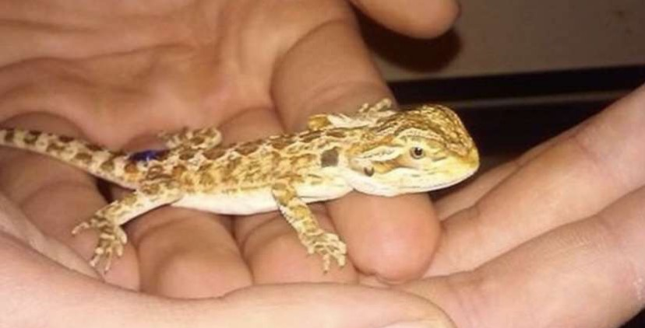

- Parade of Nations
  - Come through!! FASA and CASA are participating so it would be awesome to see some ESC love in the ballroom <3
  - Thursday, February 17th at 5PM, SURC Ballroom.
- Website
  - “Enough is Enough” formal statement
    - This will be posted under the “Director of Equity and Community Affairs” (which will soon be changed to “About the Equity & Multicultural Affairs Office” once I can get tech support to change the tab names).
    - We just need org approval on the wording at the beginning and end of the document, given the statement in the middle has already been approved and posted.
  - Organization Directory
    - Please update the comprehensive calendar with any meeting time/location/frequency changes! This is what I reference when updating the website & social media.
- Social Media
  - We are looking to get more active on the ESC social media accounts, particularly Instagram. Keep your eyes peeled for new content in the next few weeks.
  - If you have anything you would like us to post, go ahead and either tag @escatcwu or dm it to the account and I will get that posted. I have notifications turned on for every org account so I repost as I see it but dming is the best way to guarantee it gets posted.
- Showtime at Central
  - February 26th at 7PM in the SURC Ballroom
  - If you or someone you know has a talent they would like to show off, sign up to compete at Showtime at Central!
    - Cash prizes – First place: $100, second place: $50, third place: $25
    - This event is based off Showtime at the Apollo. If you are not familiar with the show, it is very YouTube-able, and I highly recommend that you do to know the style of the show before entering!
  - Virtual audition signup link: https://forms.office.com/Pages/ResponsePage.aspx?id=wdaR-NaRS0SnANNxkQcWxzTHzCn1WRpFvbwh2wv71dRUNko3QUI3VkEwWk81NDVOSDI4MUlYRUxNUy4u
    - Link can also be found in BSU’s Instagram bio
  - Traditions Keeper – attending Showtime can count towards earning your Traditions Keeper medals/medallion!
    - For those who don’t know, the Traditions Keeper is an program/app that ASCWU launched where you take photos or upload other documents to show that you attended various events. You get a bronze, silver, and gold medals, then a medallion based on the number of traditions you complete, which you can wear at graduation! It’s a great way to get more involved on campus.
    - Available for both Apple and Android OS.
  - Contact BSU if you have any questions!
    - Instagram: CWU_BSU

ESC Advisor: Justin Santoli, he/him/his, email: Justin.Santoli@cwu.edu
- Graduation Planning Meetings will begin taking place during second hour of our ESC Meetings – First one is TODAY! If you or anyone you know is helping to plan one of our graduations, please encourage them to attend.
- Upcoming DEC Events:
  - Womens Herstory Month Collage Making – Feb 15th, 5-6 pm, Black 105
  - Q*Art – Feb 18th, 3:30-4:30, Black 105
  - Find Your People – co-hosted by CASA, Feb 18th, 5-7 pm, Black Hall 105
  - USHLI Conference
Graduate Assistant: Maritsa Rodriguez

Old Business:

- No old business

New Business:

“Enough is Enough” Formal Statement
- Org approval needed before posting to ESC website

Motion to approve: BSU
Seconded by: CASA
Motion passes: 6-0-1

Student Senate ESC Representatives
Jaeda
- Spring event planning
- Defining what ESC rep
  - Liaison between each org and ESC
- Office hours
  - At DEC on Tuesdays @ 10-11am
Ibtisam
- Office hours
  - Mon & Wed at SURC 236 12-1pm

Issues/ Concerns/ Announcements:

Public Comments:
Arryn Welty (she/her) – Wellness Center
- Thank you to everyone who helped at Wellness check day!
- Recovery ally training
  - Contact Elizabeth
  - Info on Teams
  - Control Z reverse button hack on computer!
Random Act of Kindness
- Slice will be tabling in SURC
- 10-2pm on Feb 14-17th

Adjournment:1:51pm

Next meeting February 18th, 2022, at 1:00 p.m.

