Equity & Services Council
Minutes
February 25th, 2022
Friday at 1:00 p.m.
Call to Order:

- BSU
- CASA
- EQuAl
- LSO
- FASA
- MEChA
- AUAP
- FGSO (tardy)

Other Attendees/ Non-Voting Members:
Wellness Center - Arryn Welty (she/her)
SURC Accounting - Brandon Wear-Grimm (he/him)

Approval of Meeting Minutes:
Motion to approve: CASA
Seconded by: BSU
Motion passes: 7-0-1

Additions or Corrections to Agenda:

Approval of Agenda:
Motion to approve: BSU
Seconded by: EQuAl
Motion Passes: 7-0-1

Org Report:
AUAP- Nina-Kamea Nickel
- Japanese Culture Nights
BSU - Solomon Kairu (he/him)
- We had our final Zoom meeting of the quarter on Tuesday
  - Our meeting was about the discussion of the commodification of the black body
  - Our next meeting will be in person this time at Black 150 on Tuesday @5:30
  - We’re also doing well with our Black Grad and have our meetings on Thursdays @5
CASA – Atong
- 5-6:30pm today – social vs societal norms
- African night planning
EQuAl – Mayyadah (she/they)
- Pride committee meetings on Fridays at 2pm
FASA – Patricia
- In person meeting last night
- Pros and cons of PON as a board
  - Feedback w general meeting
- Informational meeting and committee development for Fil grad and Barrio Fiesta event
- Typhoon fundraiser
  - Ends on March 7th
  - Check FASA social media
- Pinoy/pinay retreat next Thursday
  - Language workshop
  - After college workshop
  - Hybrid – ShawSmyser
FGSO - tardy
LSO – Celeste
- Still looking for new officers – secretary, treasurer, social media coordinator, Vice President
MECHA - Randy
- We were able to get org T-shirts for board and advisors ordered, we will be opening sign up for members to get T-shirts soon>will be asking for these funds beginning next quarter
- Very successful meeting this past Wednesday, social meeting wanting to connect more with members
- Raices Grad committee> meet on Thursdays @3:30pm via Zoom
  - Discord channel for communication
  - Links can be found on our linktree> https://linktr.ee/mechadecwu
- Last meeting Wed., March 9th Black 202 @5pm
- Study Night next week Wed., March 2nd @5-7:30pm Brooks Library Fishbowl

ESC Executive Board Report
ESC Chair: Mariah Minjarez, email: ASCWU.Equity@cwu.edu
- Next ASCWU Public Meeitng will be on Monday, March 7th at 1 PM in the SURC Pit
- ASCWU Board Updates
  - Geoffrey and the ASCWU board created a proposal to remove faculty and staff as voting members on the S & A Fee Committee.
    - https://cwuwildcat.sharepoint.com/:w:/r/sites/ASCWU-BOD/Shared%20Documents/General/ASCWU%20Resolution%5B12%5D.docx?d=wc3175712681348379f34bf984b1fe15b&csf=1&web=1&e=OylDln
  - ASCWU Optional Study Sessions
    - You are all more than welcome to join us!
    - Every Monday from 4-6 in the Fishbowl
    - Every Wednesday from 4-7 in the ASCWU Conference room
  - ASCWU Election Updates
    - Write- In Candidate deadline is Friday, February 25th at 4:00 pm
- CCI Open Forum time change
  - The open forum will still be held on Thursday March 3rd. We changed the time to 4-5 pm due to a time conflict with other open forums occurring that same day.
  - We will also be tabling in the SURC that day from 11-1 to encourage more students to attend the Open Forum.
    - Please help spread the word to your org members and friends!
      - If anyone wants to help tabling, please let me know!
- Important Upcoming Dates:
  - March 1st is the last day to submit scholarships!
  - Please do not forget to enroll in Spring Quarter classes
  - Classes end on March 11th
  - Final Exams will occur March 15th-18th
    - You all are going to do amazing 😊
- In light of what is currently happening in Ukraine, I wanted you all to know that there are resources available if you need any support during these tough times.

Executive Assistant: Andrea Gaeta, she/her/ella, Email: ASCWUCommunityAsst@cwu.edu
- Keep submitting y’all’s hours!
  - Thank you for those who have been doing so 😊
- CCI Open forum and tabling for CCI are Civic Engagement hour opportunities
- Funding request meeting next week!
Community Programmer: Judy Brewer, she/her, they/them. ASCWUProgrammer@cwu.edu
- Hey all! Sorry I can’t be here this week. I am taking a mental health day, as pursuing a protection order has proven to be very mentally draining. I am hoping to be back in the swing of things next week 😄
- On a lighter note, here is Mushu enjoying a nice sunbathe:

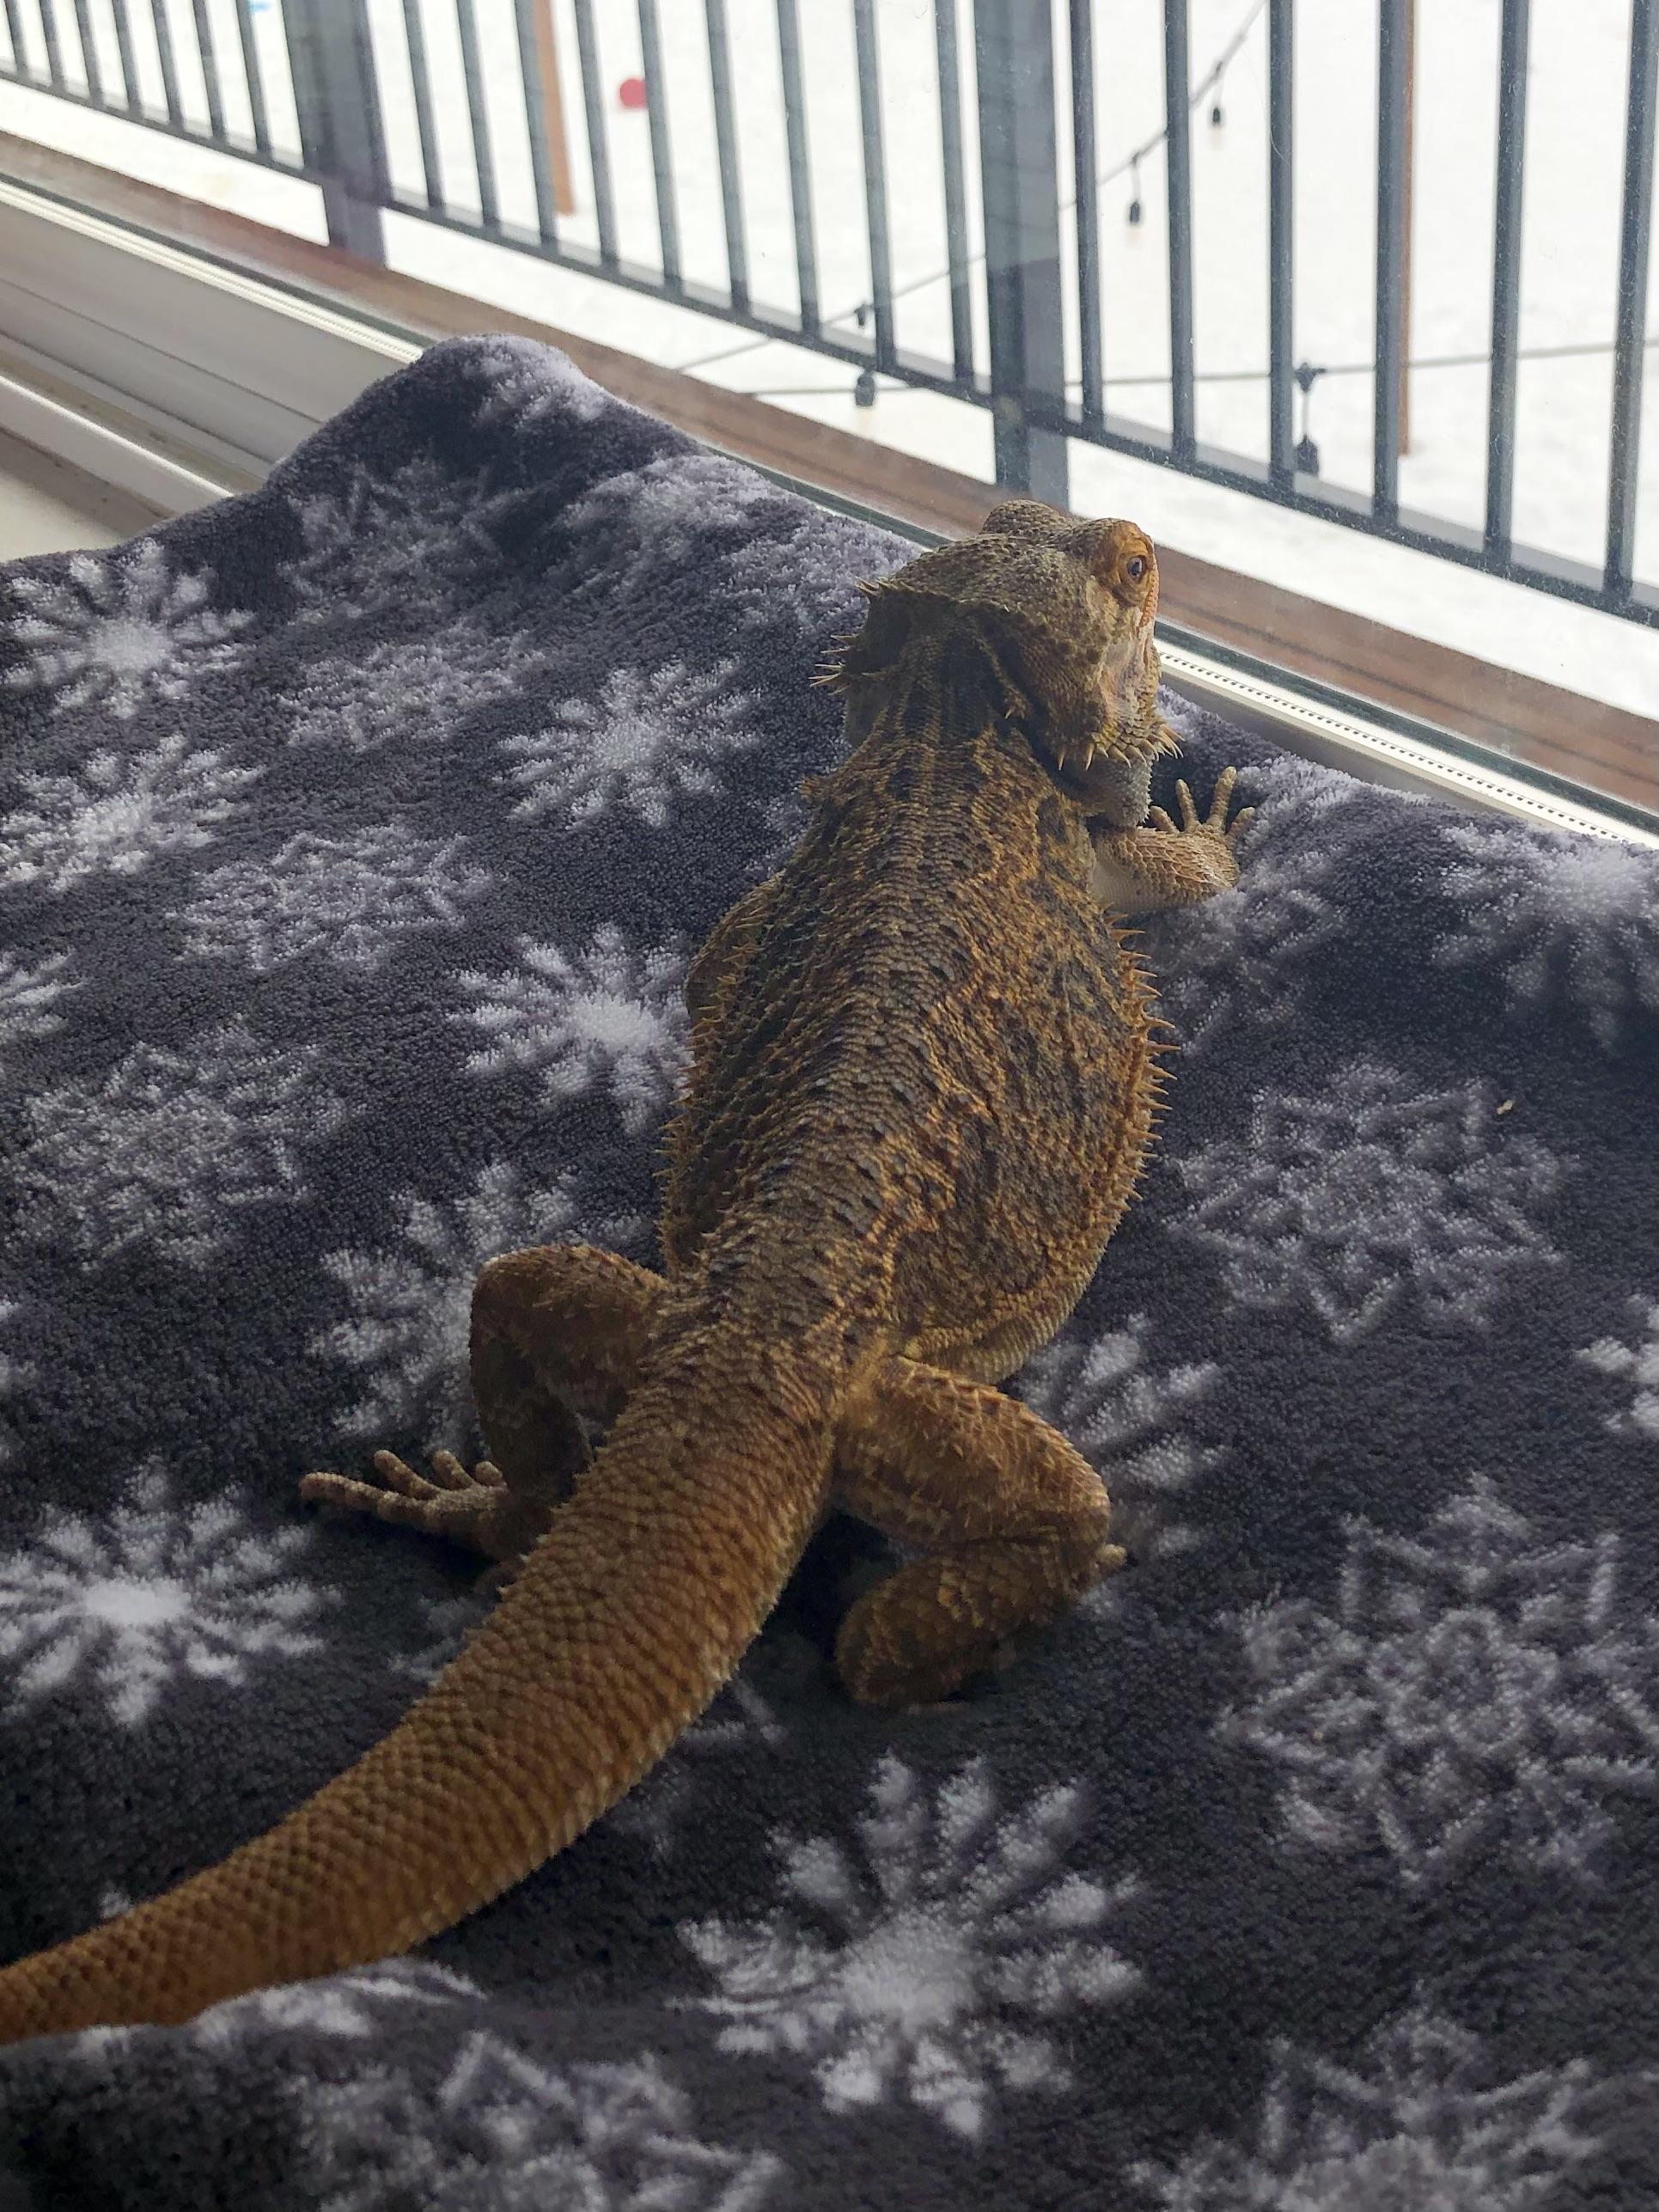

- The ESC Website has a slightly new format!
  - Combined “Funds Request” and “ESC Forms”, all forms are now available under the “ESC Forms” tab.
  - Next steps:
    - Graduation info & FAQs, under a new tab.
      - Graduation registration form will be under both the graduation and ESC Forms tab.
    - Step-by-step ESC organization recognition guide
      - This will be filed on the ESC Forms tab under “Prospective ESC Organizations”
    - Linking the “Enough is Enough” formal statement once I have the go ahead from ASCWU.
- PolyCentral reached out and is interested in coming back to campus! They are hoping to bring back PolyFest next quarter so I am helping them figure out if/how we can make it happen. Please show them some love and spread the word!
  - Instagram: @cwu.polycentral
- The Observer released an in-depth article earlier this week for Parade of Nations!
  - Link: https://cwuobserver.com/21608/scene/parade-of-nations-watch-us-rise/
  - Big thank you to everyone who attended, participated, or otherwise supported 😄
- Spring event
  - I am still exploring options for next quarter’s programmer-sponsored event! Feel free to reach out if you have any questions or suggestions.

ESC Advisor: Justin Santoli, he/him/his, email: Justin.Santoli@cwu.edu
- Graduation Updates: 73 folks registered so far!
- Spring Programming Calendar: collective program schedule from Robbi in Campus Activities – Are there any major ESC events I should input into there with mostly-confirmed dates? Pride Week/Barrio/Etc?
- Please, please, please consult the ESC Comprehensive as you plan for Spring Quarter! We don’t want orgs competing for attendance to programs!
- The College of Education will be hosting a moment of silence outside of Black Hall on Monday for Ukraine. 12pm
Graduate Assistant: Maritsa Rodriguez
- Successful FYP CASA was last week
- FYP NASU – March 3rd at 1pm Black 105

Old Business:
- No Old Business

New Business:
- Please reach out if your org needs any additional support
  - We are hoping to start tabling more starting next quarter if anyone is interested in joining us.

Student Senate ESC Representatives
- End of year ESC celebration next quarter
- PUSH is doing a volunteer event from 4-6pm at library

Issues/ Concerns/ Announcements:

Public Comments:
Arryn Welty (she/her)
- Show Up Speak Out Event – April, Sexual Assault Awareness Month, April 26th
  - Dedicated tables for individual org/club
  - Supporting in sexual assault awareness
  - Call for performances (“Speak Out”)
  - To participate: https://cwu.co1.qualtrics.com/jfe/form/SV_diB5TU9NCZe8hZs
    - Due March 18th at 5pm
    - Questions/concerns: Katie.Park@cwu.edu

Adjournment: 1:46pm

Next meeting March 4th, 2022, at 1:00 p.m.

